**Browser geolocation and how it works**

To detect the location of a client device in the past, one would typically have to inspect the client IP address and make a reasonable guess as to the where that device was located. However, as part of the HTML5 efforts, the W3C has developed a set of APIs to effectively allow the client-side device (i.e. your iPhone 3G+, Android 2.0+ phones, or even your conventional desktop browsers) to retrieve geographic positioning information with JavaScript.

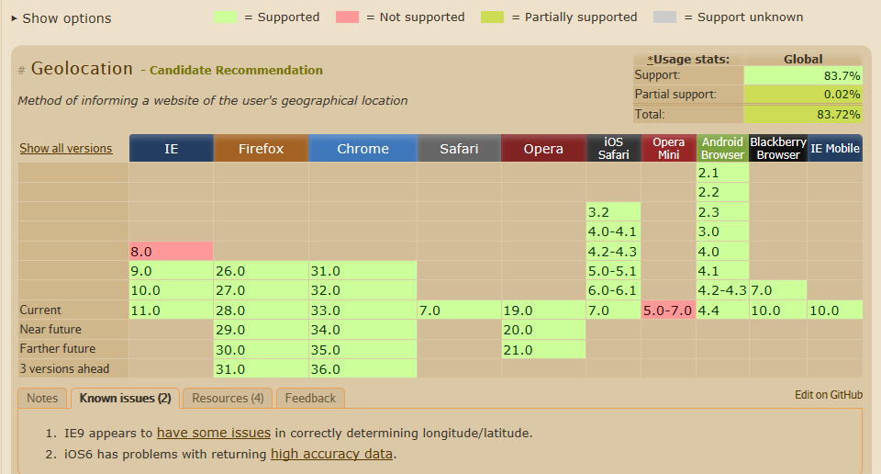

The Geolocation API of HTML5 helps in identifying the user’s location, which can be used to provide location specific information or route navigation details to the user.

There are many techniques used to identify the location of the user.

A desktop browser generally uses WIFI or IP based positioning techniques whereas a mobile browser uses cell triangulation, GPS, A-GPS, WIFI based positioning techniques, etc. The Geolocation API will use any one of these techniques to identify the user’s location. The geolocation API won't identify how location information was determined. Not knowing how geolocation was achieved is usually not a problem, but you may notice that the accuracy of location information may vary greatly depending on the technique used. No guarantee is given that the API returns the device's actual location.

The Geolocation API protects the user’s privacy by mandating that the user permission should be sought and obtained before sending the location information of the user to any website. So the user will be prompted with a popover or dialog requesting for the user’s permission to share the location information. The user can accept or deny the request.

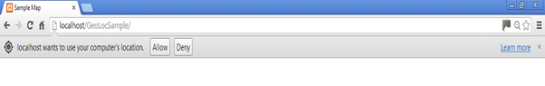

Let’s get started

1. The first step in using any of the APIs in HTML5 is to check for its compatibility with the browser.

## A browser that supports the Geolocation API provides the navigator object with a new property i.e. Geolocation object. This object can be used to retrieve location info.

## Basically what this code is doing is:

## Checking if the navigator has a geolocation object associated with it, if it has then it goes into the if part (blank at the moment) otherwise it display a message in the <p> tag called demo… find an element that has the id “demo” and replace its text with the message.

## 

## Get the user’s current location

The current location of the user can be obtained using the getCurrentPosition function of the navigator.geolocation object. When called, it must immediately return and then asynchronously acquire a new Position object.

This function accepts three parameters – Success callback function (in our example this is called showPosition), Error callback function and position options. If the location data is fetched successfully, the success callback function will be invoked with the obtained position object as as an argument. Otherwise, the error callback function will be invoked with the error object as as an argument.

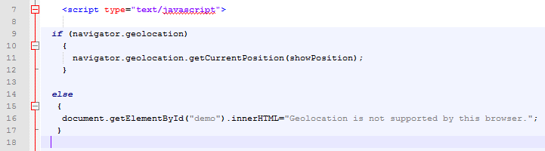

1. Success callback function (showPosition)

This callback function is invoked only when the user accepts to share the location information and the location data is successfully fetched by the browser. The location data will be available as a position object and the function will be called with the position object as its input parameter.

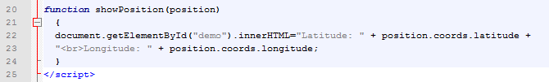

1. When you save and run this file you will get the following prompt. This just says the page wants to run some javascript. Click Allow.



1. Click Allow once to allow the geolocation to work.



Add a button to call the geolocation code

The following code takes the code you have just written and puts in into a function that is called only when the user clicks a button.

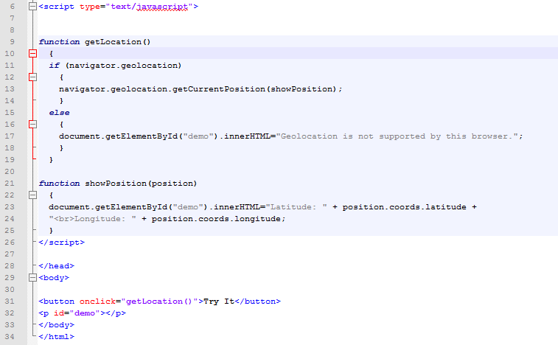

Calculate the distance between 2 points

The following code calculates the distance between 2 points. It uses a function called getDistanceFromLatLonInKm() which is located in the distancecalc.js file.

* You pass 4 values to the function, the first 2 values are the known co-ordinates of some location and the next 2 are the co-ordinates of where the user is. The function calculates the distance between these.

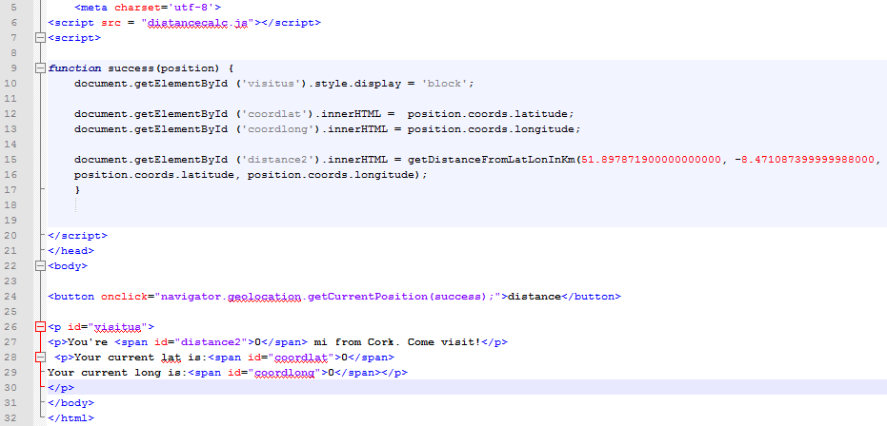

Visit the following site for more information on geolocation. <http://www.sitepoint.com/html5-geolocation/>

Figure out the location of a device

There are a variety of techniques and sensor data that modern mobile devices can tap to figure out the location of a device with varying degrees of accuracy. The most common are discussed briefly below.

Some popular mobile devices — like the iPhone and Android phones — support two methods of figuring out where you are. The first method triangulates your position based on your relative proximity to different cellular towers operated by your phone carrier. An approximate location can be calculated by using information about the location of the cell towers that a mobile device is connected to at any time.

This method is fast and doesn’t require any dedicated GPS hardware, but it only gives you a rough idea of where you are. Depending on how many cell towers are in your area, “a rough idea” could be as little as one city block or as much as a kilometer in every direction.

The second method actually uses dedicated GPS hardware on your device to talk to dedicated GPS positioning satellites that are orbiting the Earth. GPS geolocation works by detecting the signal from these satellites, typically four or more; by using a mathematical technique called trilateration the device can determine its location based on the timing of the statellite signals.

GPS can usually pinpoint your location within a few meters. The downside is that the dedicated GPS chip on your device draws a lot of power, so phones and other general purpose mobile devices usually turn off the chip until it’s needed. That means there will be a startup delay while the chip is initializing its connection with the GPS satellites in the sky. It also requires a clear view of the sky, so if you're indoors, you're out of luck.

If you’ve ever used Google Maps o an iPhone or other smartphone, you’ve seen both methods in action. First you see a large circle that approximates your position (finding the nearest cell tower), then a smaller circle (triangulating with other cell towers), then a single dot with an exaction position (given by GPS satellites).

The reason I mention this is that, depending on your web application, you may not need high accuracy. If you’re just looking for nearby movie listings, a “low accuracy” location is probably good enough. There aren’t that many movie theaters, even in dense cities, and you’ll probably be listing more than one of them anyway. On the other hand, if you’re giving turn by turn directions in real time, you really do need to know exactly where the user is so you can say “turn right in 20 meters” or whatever.

Others include:

* A-GPS (assistive GPS) uses triangulation between mobile phone towers and public masts to determine location. Although not as precise as GPS, A-GPS is sufficient for many scenarios.
* Mobile devices that support Wi-Fi access points can use hotspots to determine the user’s location.
* Stationary computers without wireless devices can obtain rough location information using known IP address ranges.